 **Department of Mechanical and Industrial Engineering**

Program: Mechanical Engineering

| Course Number | MEC733 |
| --- | --- |
| Course Title | Microprocessor System |
| Semester/Year | 2021 |
| Instructor | Dr. Siyuan He |

| **MEC733 PROJECT** |
| --- |

| Report Title | Project Report |
| --- | --- |

| Group No. |  |
| --- | --- |
| Submission Date | April 15, 2021 |
| Due Date | April 15, 2021 |

| Name | Student ID | Section No. | Signature* |
| --- | --- | --- | --- |
| Edwin Quang Trinh | 15360 | 04 |  |
| Jayson Tong | 82242 | 10 |  |
| Christopher Plant | 05264 | 09 |  |
| Ryan Chen | 90697 | 04 |  |

(Note: remove the first 4 digits from your student ID)

*\*By signing above you attest that you have contributed to this submission and confirm that all work you have contributed to this submission is your own work. Any suspicion of copying or plagiarism in this work will result in an investigation of Academic Misconduct and may result in a “0” on the work, an “F” in the course, or possibly more severe penalties, as well as a Disciplinary Notice on your academic record under the Student Code of Academic Conduct, which can be found online at:*

*http://www.ryerson.ca/senate/policies/pol60.pdf. .*

# Table of Contents

**Table of Contents** **2**

**Introduction** **3**

**Apparatus** **3**

**Discussion** **4**

**Conclusion** **5**

**Appendix 1: Program Code** **6**

**Appendix 2: Photos** **8**

# 

# Introduction

The purpose of this project is to use the knowledge gained over the various labs and lectures over the year into coding the Arduino UNO R3 Board that was attached onto the ‘Smart Robot Car Kit 3.0 Plus.’ The task of the project was to drive the robot car to follow a black circle that is outlined using black, electric adhesive tape. Assembling the Elegoo Smart Robot Car, the line tracker photo sensors that were attached to the Robot Car will be coded using Arduino C programming to tell the program when each sensor was activated. With the knowledge of when each sensor was in use, the program will determine the motor's speed in accordance with the direction required. Using the example described in Week 12 of the Lectures and digitalWrite, digitalRead, #define, and analogWrite the car was coded to follow the requirements of following the circle as quickly and smoothly as possible. With the circle being defined as small as possible, it results in a high car program follow capability.

# Apparatus

The parts used in this project comes from the ‘Smart Robot Car Kit 3.0 Plus’ from Elegoo. The major parts that are being used for this project consist of:

* Four DC motors
* Top and bottom acrylic chassis
* L298N motor module
* Line tracking module
* UNO R3 board
* IO expansion board
* Corresponding cables
* Screws, nuts, and standoffs
* Cell box (Lithium battery inside)
* Black PVC tape
* Arduino IDE

# **Discussion**

The code works by continually reading the values of the three line tracking sensors that are connected to the car. If the middle sensor is high then both engines stay at the same speed and go forward. If the right sensor is high then the right engine speed is increased by max_vs and the left engine is decreased by the same amount causing the car to turn right. If the left sensor is high then the left engine speed is increased by max_vs and the right engine is decreased by the same amount causing the car to turn right. By continually reading in the sensor values the car is able to accurately follow the circle by continually adjusting the motor speeds.

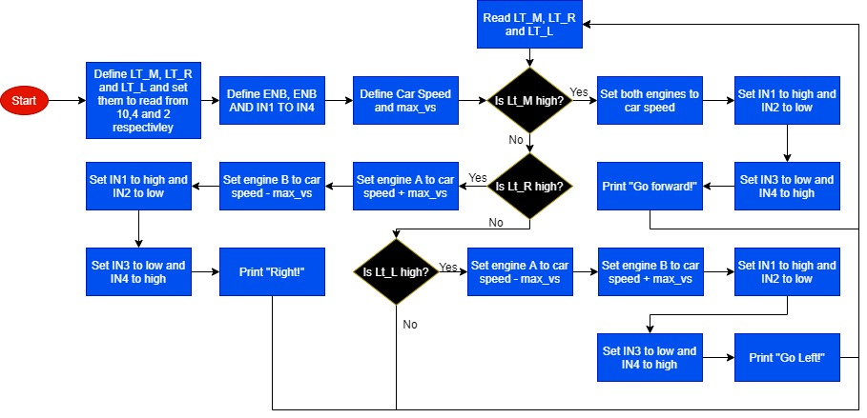

Figure 1: Flowchart for Program

# Conclusion

In conclusion, the method that was used to ensure smooth movement of the ELEGOO Robot car was similar to the examples that were taught during week 12 of class. The method was based primarily on functions that would define each movement; back, left, right, forward and stop. Alongside defining each pin on the L298 motor module with the IO expansion board that was connected to the Arduino UNO R3 board (e.g #define ENA 5, #define ENB 6 e.t.c.), 2 other variables were defined; max_vs and carSpeed. Max_vs was a variable constant defined as 80 and was used to define the increment that the variable carSpeed would increase or decrease by depending on the direction. carSpeed was a variable that was defined as 120. Using analogWrite to define each motor speed, and digitalWrite to define which signals to run with each motor allowed for easy motor control. Ultimately, using a circle of a 12 inch diameter, the Elegoo Robot car was able to satisfy the requirements of following the circle as quickly and smoothly as possible using Arduino C programming.

# Appendix 1: Program Code

//Line Tracking IO define

#define LT_R !digitalRead(10)

#define LT_M !digitalRead(4)

#define LT_L !digitalRead(2)

#define ENA 5

#define ENB 6

#define IN1 7

#define IN2 8

#define IN3 9

#define IN4 11

#define carSpeed 120

float max_vs = 80;

void forward(){

analogWrite(ENA, carSpeed);

analogWrite(ENB, carSpeed);

digitalWrite(IN1, HIGH);

digitalWrite(IN2, LOW);

digitalWrite(IN3, LOW);

digitalWrite(IN4, HIGH);

Serial.println("go forward!");

}

void left(){

analogWrite(ENA, carSpeed-max_vs);

analogWrite(ENB, carSpeed+max_vs);

digitalWrite(IN1, HIGH);

digitalWrite(IN2, LOW);

digitalWrite(IN3, LOW);

digitalWrite(IN4, HIGH);

Serial.println("go left!");

}

void right(){

analogWrite(ENA, carSpeed+max_vs);

analogWrite(ENB, carSpeed-max_vs);

digitalWrite(IN1, HIGH);

digitalWrite(IN2, LOW);

digitalWrite(IN3, LOW);

digitalWrite(IN4, HIGH);

Serial.println("go right!");

}

void setup(){

Serial.begin(9600);

pinMode(10,INPUT);

pinMode(4,INPUT);

pinMode(2,INPUT);

}

void loop() {

if(LT_M){

forward();

}

else if(LT_R) {

right();

while (LT_R);

}

else if(LT_L) {

left();

while (LT_L);

}

}

# Appendix 2: Photos



